6.30: The work can be found by finding the area under the graph, being careful of the sign of the force. The area under each triangle is 1/2 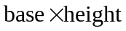.
a) 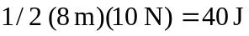.
b) 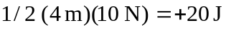.
c) 

